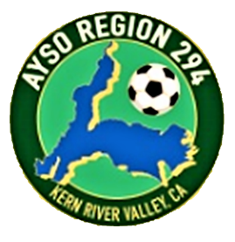
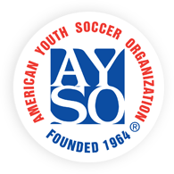

Refunds
Fall Season 2024

AYSO is a non-profit, 100% volunteer-run organization. All registration fees cover the player's uniform (excluding shin guards and shoes), medal, park permits, coach/ref equipment, volunteer training, insurance, and more and are broken into three categories:

- Regional fee used for the costs to run the regional soccer program (may be refundable)
- National fee used for insurance and administration of the player (non-transferable, non-refundable)
- Transaction fees paid to companies like Sports Connect to handle payment transactions (non-refundable, non-transferable)

Refund Policy:
- The non-refundable portion of each player's registration fee is $25.00 plus the fees for credit card processing. Therefore, the refund will be the total amount paid minus $25.00, minus the credit card processing fees, if the request is received before noon September 1, 2024.
- No refund will be given for the cost of a uniform that has been issued and worn.
- To request a refund, send an email to mrsjspeakman@hotmail.com. The refund will be issued by check. No refunds after 12 noon on September 1, 2024. The date and time of your email is your request date.

